# Fall 2019 MSCR 500 & 533 Quiz 2

**Student Name: ________________________**

Read the following carefully before beginning…

## You must work completely on your own. You may not receive assistance from anyone except the course instructor. You may not give assistance to anyone.

* **While working on this quiz, you may not communicate with anyone, in any manner, direct or indirect, except for the course instructor.**
* **Either:**
  + Print this quiz out, write your answers on it, and then scan and upload to Canvas (under Quiz 2) or
  + Type your answers into this Word document, save and upload to Canvas (under Quiz 2)

## Make sure your full name is in the name of the file that you upload, and also on this cover page.

* This is an open-notes and open-book quiz. You may also use any materials posted on our Canvas site. You may use internet searches for SAS help, if needed.
* You may use a scientific calculator (or calculator app on your phone/tablet)
* Do not use SAS or any other statistical/mathematical software for questions 1 and 2.
* Use SAS (but not any other statistical/mathematical/spreadsheet software) for Q3.
* On questions 1 and 2, in order to maximize your chances of getting partial credit, show all work on parts of problems that require calculations to be performed. Clearly show formulas that you are using, and identify values that are being “plugged” in.
* For questions 1 and 2, use only the statistical tables in the Weiss text. Do not use tables from any other source, or any software/apps for this purpose.

# No time limit; but do upload your quiz document to Canvas no later than 11:59pm on Wednesday, 11/27.

**There are 9 pages in this quiz**

­­­­­­Q. 1 This question will count towards your MSCR 500 Quiz 2 score.

A study was conducted to examine the long-term effects of radial keratotomy, a type of surgery to correct myopia (near-sightedness.) After an initial pilot phase, in which 44 patients received the surgery, 310 additional or “core study” patients received the surgery. All 354 patients were followed for a period of ten years after surgery. The refractive error (a measure, in diopters, of how near- or far-sighted a patient is) was measured ten years after surgery was recorded.

One question of interest in the study was: “is the long-run change in refractive error different for pilot and “core study” subjects?” To answer this question, the change in refractive error between 1 year post-op and 10 years post-op was calculated (CHG = 10 yr refractive error – 1 yr refractive error) for each patient.

Use the edited SAS output below and on page 3 to investigate whether the change in refractive error is different for pilot and core patients. Use α=0.10.

**Write your answers in the spaces provided on page 4.**

------------------------------------------ Pilot Patients ------------------------------------------

Univariate Procedure

Variable=CHG

Moments

N 44 Sum Wgts 44

Mean 0.744318 Sum 32.75

Std Dev 1.02829 Variance 1.05738

Skewness 2.208812 Kurtosis 7.397643

USS 69.84375 CSS 45.46733

CV 138.1519 Std Mean 0.155021

Stem Leaf # Boxplot

2

2 0 1 |

1 6669 4 |

1 000011224 9 +-----+

0 5555556666888 13 *--+--*

0 001222444 9 +-----+

-0 44411 5 |

-0 95 2 |

----+----+----+----+

Normal Probability Plot

2.25+

| *** *

| **** **

| ******

| ******

| **

-0.75+ *

+----+----+----+----+----+----+----+----+----+----+

-2 -1 0 +1 +2

----------------------------------------- Core Patients -------------------------------------------

Univariate Procedure

Variable=CHG

Moments

N 310 Sum Wgts 310

Mean 0.717419 Sum 222.4

Std Dev 1.061279 Variance 1.126314

Skewness 0.239009 Kurtosis 4.923359

USS 507.585 CSS 348.0309

CV 147.9301 Std Mean 0.060277

Histogram #

6.25+ Boxplot

.

.* 1 0

.** 3 0

.***** 9 |

.********* 18 |

.************* 26 |

.**************************** 55 +-----+

0.75+*************************************** 78 *--+--*

.******************************* 62 +-----+

.******************* 37 |

.****** 11 |

.* 2 |

.* 1 0

.** 3 0

.* 1

.

-4.75+

----+----+----+----+----+----+----+----

* may represent up to 2 counts

Normal Probability Plot

6.25+

|

| *

| ***

| ****

| ****

| ****

| *******

0.75+ *******

| *******

| *******

| ****

| *

| *

| ***

|*

|

-4.75+

+----+----+----+----+----+----+----+----+----+----+

-2 -1 0 +1 +2

**Fill in your answer to Q. 1 below…**

**Hypotheses: __________________ Define Parameter(s): ___________________________**

**­­__________________ ___________________________**

**Name of test: ___________________________**

**Justification for using this particular test: ____________________________________________**

**_________________________________________________________________________________**

**_________________________________________________________________________________**

**_________________________________________________________________________________**

**Test Statistic (show all computation details):**

**P-value (show all details, including the probability expression that needs to be evaluated):**

**Decision (Circle One): Reject H0 at α=0.10 Fail to Reject H0 at α=0.10**

**Conclusion:______________________________________________________________________**

**_________________________________________________________________________________**

_________________________________________________________________________________________________

Q.2 This question will count towards your MSCR 500 Quiz 2 score.

Students were given a statistics pre-test. At the end of the course, a post-test was given. Was

there an improvement in test scores? Perform the appropriate test (**fill in your answers on page 6**). Use the SAS output below (generated by the SAS program below) to save yourself *some* manual work, but otherwise do not use SAS software or any other software!

DATA;

INPUT student posttest pretest;

Difference = posttest - pretest;

DATALINES;

1 50 60

2 60 60

3 40 50

4 30 90

5 30 60

6 70 90

7 80 60

8 20 40

9 80 80

10 90 80

11 50 60

12 60 60

13 40 50

14 30 90

15 30 60

16 70 90

17 80 60

18 20 40

19 80 80

20 90 80

;

RUN;

PROC UNIVARIATE;

VAR difference;

PROBPLOT difference;

RUN;

Data: Test scores

--------------------------------

Student Post-test Pre-test

-------- ---------- -------------

1 50 60

2 60 60

3 40 50

4 30 90

5 30 60

6 70 90

7 80 60

8 20 40

9 80 80

10 90 80

11 50 60

12 60 60

13 40 50

14 30 90

15 30 60

16 70 90

17 80 60

18 20 40

19 80 80

20 90 80

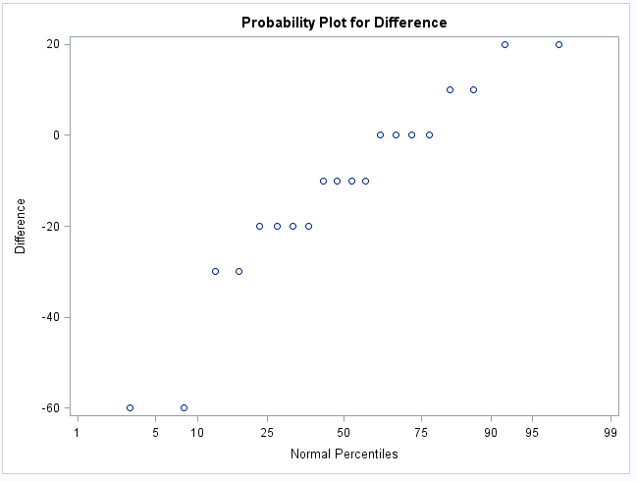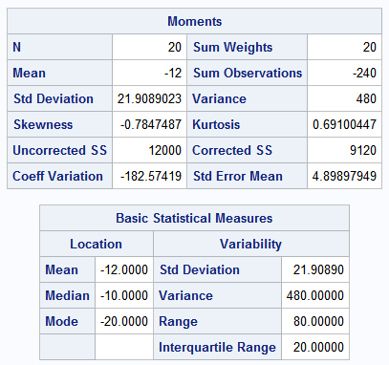

**Fill in your answer to Q. 2 below…**

**Hypotheses: __________________ Define Parameter(s): ___________________________**

**­­__________________ ___________________________**

**Name of test: __________________________________________________________**

**Justification for using this particular test: ____________________________________________**

**_________________________________________________________________________________**

**_________________________________________________________________________________**

**_________________________________________________________________________________**

**Test Statistic (show all computation details, *except for* any values that can be taken directly from the output on the previous page:**

**P-value (show all details, including the probability expression that needs to be evaluated):**

**Decision (Circle One): Reject H0 at α=0.05 Fail to Reject H0 at α=0.05**

**Conclusion:______________________________________________________________________**

**_________________________________________________________________________________**

_________________________________________________________________________________________________

­­­­­­­_________________________________________________________________________________________________

**Q3.** This question will count towards your MSCR 533 Quiz 2.

A sample was collected of sandwiches commonly sold at campus eateries, and various characteristics of the sandwiches were recorded. The data were recorded in the Excel files ‘sandwich_name.xls’ and ‘sandwich_nutrition.xls’. The files contain the following variables:

**sandwich_name.xls:**

**Variable Name Variable Description**

Sandwich_Number an identifier

Brand sandwich brand

Name sandwich name

Category sandwich category (Fish, Beef, etc.)

Frozen an indicator of whether the sandwich was fresh or frozen

**sandwich_nutrition.xls:**

**Variable Name Variable Description**

Sandwich_Number an identifier

Calories number of calories

TFat total fat content, in grams

Protein protein content, in grams

Carb carbohydrate content, in grams

Fiber fiber content, in grams

Sodium sodium content, in mg

Weight weight, in ounces

**Your tasks:**

-Import the data from the Excel files into temporary SAS data sets named ‘sandwich_name’ and ‘sandwich_nutrition’. The Excel files are on Canvas.

Next, create a concise and well-formatted SAS program that accomplishes tasks 1-6 below. Be sure to include a header comment at the top of the program containing your name, and additional descriptive comments throughout the program indicating that parts of this question that are being addressed by the various statements and sections of code. Your SAS program should do, or allow you to do, the following, *in order*:

1) Examine the contents of the two temporary data sets.

2) Merge the two temporary data sets, by sandwich_number, into a single temporary data set named ‘sandwiches’.

3) Perform descriptive analyses for each variable in the merged data set.

4) Modify the merged data set as follows: change the value of ‘category’ from BEEF to Beef wherever the former exists. (HINT: use IF-THEN statements)

5) Test, at the 1% significance level, whether the average calories are different for fresh and frozen sandwiches. Write the results of your test on page 8.

6) Estimate, with 99% confidence, the difference in true average caloric content of fresh and frozen sandwiches sold at campus eateries. Write your results on page 8.

**Copy your final program from SAS and paste it onto page 9 of this Word document. This program should be “clean” –error free, and concise (no redundant data or proc steps!)**

**Fill in your answer to Q3, item 5, below:**

Hypotheses: ______________ parameter(s) used in the hypotheses: _____________

______________ __________________________________________

α = 0.01

Name of the hypothesis test: _____________________________________________________

Justification for using this particular test: _____________________________________________________________________________

_____________________________________________________________________________

Test Statistic Value (take directly from SAS output): ________________________

p-value (take directly from SAS output): ___________________

Decision (Circle One): Reject H0 at α=0.01 Fail to Reject H0 at α=0.01

Conclusion:____________________________________________________________________

______________________________________________________________________________

______________________________________________________________________________

**Fill in the following for Q3, item 6:**

Probability distribution used, and justification for using it: _____________________________________________________________________________

_____________________________________________________________________________

99% Confidence Interval Result (provide a sentence):

_____________________________________________________________________________

_____________________________________________________________________________

_____________________________________________________________________________

**Paste your final program from SAS onto this page:**